ELLSBURG TOWNSHIP ANNUAL TOWNSHIP MEETING March 12, 2024

The meeting was called to order at 8:30 pm in the Melrude Town hall, followed by the Pledge of Allegiance.

Residents and guests present were Chairman Beth Caple, Supervisor John Upton, Clerk Cindy Brown, Deputy Treasurer Elaine Wick, Treasurer Scott Streitz, Deputy Clerk Steph Upton, Travis Denzler, Tim Linder, Heidi Yokel, Loren Mesedahl, Loren Mesedahl Jr, and Dale Wick.

Heidi Yokel made a motion to nominate Beth Caple as moderator for the meeting, John Upton second, all residents agreed via show of hands, motion approved.

Clerks’ minutes for the March 2023 Annual Meeting were read.

The year-end financial report as prepared by Deputy Treasurer Elaine Wick was read.

2023 Year End Financial Report:
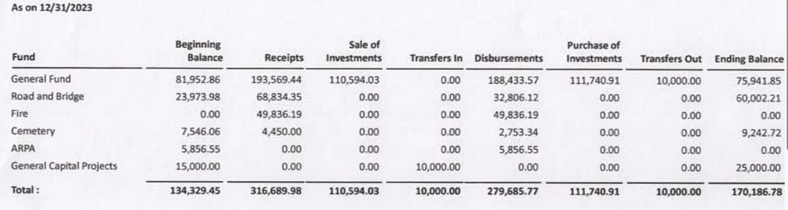

Review of 2023 activities for:

Cemetery – Chairperson Beth Caple reported that the cemetery survey was completed in 2022 and we had 3 burials in 2022.

Roads – Supervisor Kevin Davidson was absent but it was pointed out that Kevin worked with FEMA to complete the grant process to reimburse the township for the cost of repairing the roads damaged by the April 2022 floods.

Buildings – Vice Chair John Upton reported that the new building was completed in 2022 and leased to the Ellsburg Volunteer Fire Department. In their annual report the fire department expressed their gratitude for the new building and recognized John Upton for his hard work on this project. There are three projects to be completed in 2024 before the close of the IRRRB grant in September 2024: Insulating and side the block on the outside of the building, add gravel to the driveway and parking lot and epoxy coat the floor on the inside of the building.
Ellsburg Volunteer Fire Department – Fire Chief Loren Mesedahl gave a detailed report on 2023, some of the highlights are: there are currently 20 members, they responded to 26 calls in 2023 (3 were cancelled when the fire department was already underway), 10 calls were medical, 1 animal rescue, 1 lift assist and 1 welfare check. Mutual aid was provided to other departments 4 times. The Fire Department participated in the Melrude 4th of July Parade, Melrude Winter Frolic, Big Trucks Night in Cotton and at South Ridge School and hosted National Night Out. They schedule monthly training sessions which include medical topics, required OSHA training, fighting wildfires, radio usage, working with pumps, hoses and tools required for firefighting and ice/water rescue. The department is very active in wildfire prevention and will address this issue heavily in 2024 as Ellsburg has been determined by the National Fire Protection Agency as a high-risk area. Due to their hard work Ellsburg has been recognized as a Firewise USA township.

Other Township Business - Moderator Beth Caple asked if anyone had additional questions or concerns that they would like to discuss. There were no questions or concerns from the residents and guests present.

2025 Town Levy as suggested by the supervisors.

General Fund $ 57,500.00
Road Fund $ 25,000.00
Fire Fund $ 45,000.00
Total $127,500.00

Heidi Yokel made a motion to accept the levy as suggested by the town supervisors, Scott Streitz second, all residents agreed via show of hands, motion approved.

Contract for Health, Social and Recreational Services from non-profit organizations – Per statute the
township supervisors can spend no more than $10k per year. Elaine Wick made a motion to approve up to $10k, Steph Upton second, all resident agreed via show of hands, motion approved.

Fund Town Celebrations and Recognition of Service – Per statute, residents must give approval and spending limit. Steph Upton made a motion to approve a $1000 limit for town celebrations and recognition of service, Dale Wick second, all residents agreed via show of hands, motion approved.

Township Officer Election Results -

The Canvass Board certified the official election results as follows:

Candidate Votes

Supervisor: 3-year term
- Scott Streitz 24
- Arrlette Krog (write-in) 1

Clerk : 2-year term
- Cindy Brown 25
- Arrlette Krog (write-in) 1

Cotton Chronicle Donation – John Upton made a motion to request a sponsorship ad of $250.00, Scott Streitz second, all residents agreed via roll call, motion approved.

2025 Election Polling Hours – John Upton made a motion to approve Melrude Town Hall polling hours to be 12:00 pm to 8:00 pm for the 2024 Township Election, Scott Streitz second, all residents agreed via show of hands, motion approved.

2025 Annual Meeting Date – March 11, 2025 is the second Tuesday in March. John Upton made a motion to approve the meeting date, Scott Streitz second, all residents agreed via show of hands, motion approved.

Moderator Beth Caple asked the residents if they had any other items of business:

John Upton brought up the question that Cotton Township had on their ballot this year, which was to determine if the electors wanted their Clerk and Treasurer positions to be appointed going forward rather than elected positions. After a discussion it was determined that no motion would be made to add this question to our ballot next year, we will continue to have elected clerk and treasurer positions.

Travis Denzler suggested all present attend the April Lake Country Power meeting in Virginia as they are considering a bill to go to all wind/solar power which will affect all of us.

As there was no further business John Upton made a motion to adjourn the meeting, Dale Wick second, all residents agreed via show of hands, motion approved. The meeting adjourned at 9:16 pm.

___________________________ ____________________________
Cindy Brown, Clerk Beth Caple, Moderator

__________________________
Date

