**ELLSBURG TOWNSHIP MEETING** February 28, 2023

The meeting was called to order at 6:00 PM in the Ellsburg Town hall, followed by the Pledge of Allegiance.

Board members present were Chairperson Beth Caple, Supervisor John Upton, Treasurer Elaine Wick, Deputy Treasurer Scott Streitz and Clerk Cindy Brown. Vice Chair Kevin Davidson was absent.

Guests present were: Dale Wick, Tim Linder, Arrlette Krog and Loren Mesedahl.

Clerks’ minutes for January 2023 Meeting were read.

Treasurer Report for January 2023

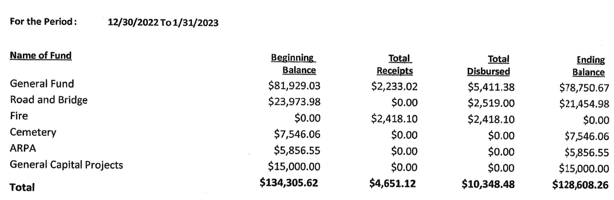

Claims for February 2023



**CONSENT AGENDA**

* January 2023 Meeting Minutes
* Bills for payment
* Payroll

Supervisor John Upton made a motion to approve consent agenda items, Chairperson Beth Caple second, motion approved.

**CORRESPONDENCE:**  No action required.

**RESIDENTS AND GUESTS:**

* Resident Arrlette Krog stated the Community Club Winter Frolic was a success, they had a beautiful day for the event and it was well received by the community.
* Fire Chief Loren Mesedahl gave a fire department report, they assisted with one fire call in Cotton and had a presentation from Firewise on wildfire management.

**OLD BUSINESS**

* **Road and Bridge:** 
  + Scott Streitz stated that there is an issue with water pooling on a section of the Mink Rd, the clerk will ask the Road Supervisor, Kevin Davidson, to take a look at it in case we need to steam a culvert to remedy the issue.
* **Buildings:**
  + Supervisor John Upton stated that the IRRRB will be sending a portion of the deposit of the grant funds to cover half of the Economy Garages deposit.
* **Cemetery:**

Nothing to report.

**NEW BUSINESS**

* The meeting minutes for the Audit Meeting, Budget Meeting and the February 21st Special Board Meeting were read. Chairperson Beth Caple made a motion to approve all three meeting minutes, Supervisor John Upton second, motion approved.
* Chairperson Beth Caple asked the fire department to select a date for a review of the fire department finances. They agreed on the date of March 29, 2023 at 6:00 pm at the Bass Lake Fire Hall.
* The clerk asked the supervisors for guidance on verbiage for this year’s road work bid request. They want to simplify the request and ask for a straight hourly rate with contractor supplied equipment for general maintenance on township roads to include grading, brushing, mowing and chloride treatment. Any work required outside of this general road work will be bid on separately.
* The annual lawn mowing bid request will be posted with an additional request for an hourly rate on general maintenance for the cemetery. Items such as seeding, adding dirt to depressed areas, removing brush or downed trees will be billed at an hourly rate, it will not be included in the standard bid request for mowing for the township.
* A short discussion on increasing lot charges for the Riverside Cemetery was held but it was decided to table the topic until March.
* Supervisor John Upton questioned if we should have the bridge on Cemetery Road inspected. The clerk will ask the road supervisor to check into an inspection.

As there was no further business, Chairperson Beth Caple made a motion to adjourn, Supervisor John Upton second, motion approved. The meeting was adjourned at 6:48 P.M.

___________________________ ____________________________

Cindy Brown, Clerk Beth Caple, Chairman

__________________________

Date