**ELLSBURG TOWNSHIP MEETING** July 25, 2023

The meeting was called to order at 6:02 PM in the Ellsburg Town hall, followed by the Pledge of Allegiance.

Board members present were Chairperson Beth Caple, Vice Chair John Upton, Treasurer Scott Streitz, Deputy Treasurer Elaine Wick and Clerk Cindy Brown. Supervisor Kevin Davidson was absent.

Guests present were: Lee Voigt, Jeff Johnson, Heidi Yokel and Jane Kempton.

Clerks’ minutes for June 2023 Meeting were read.

Treasurers Report for July

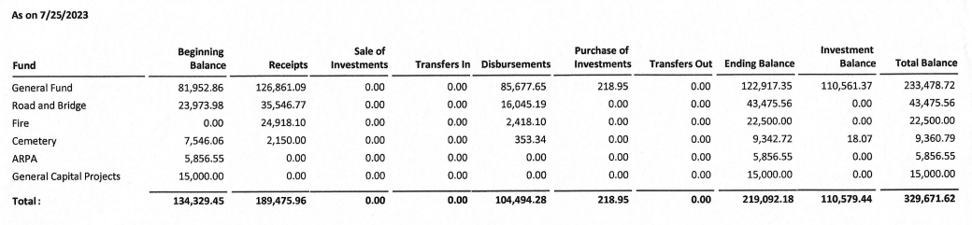

Claims for July 2023



**CONSENT AGENDA**

* June 2023 Meeting Minutes
* Treasurer Report and Bills for payment
* Payroll

Vice Chair John Upton made a motion to approve consent agenda items, Chairperson Beth Caple second, motion approved.

**CORRESPONDENCE:**  Donation requests were received and Chairperson Beth Caple made a motion to approve, Vice Chair John Upton second, motion approved – $200 for SLC Sheriff Rescue Squad and $200 for National Night Out hosted by the Ellsburg Volunteer Fire Department.

**RESIDENTS AND GUESTS:**

* Heidi Yokel gave a EVFD report. They had 1 call in July and participated in the Fourth of July parade held in Melrude. They will host National Night Out at the Bass Lake Fire Hall on Tuesday, August 1 from 5:00 – 7:00. Heidi informed everyone that there will be a Lee Leighton Memorial held at the corner of Comstock Lake Rd and Water Hen Rd on August 26th at 1:00 pm.

**OLD BUSINESS**

* **Road and Bridge:** 
  + New culverts have been installed on Nelson Road.
  + FEMA approved the spring flooding disaster within St Louis County. Several roads in Ellsburg Township were affected by the flooding. There will be a meeting Thursday, August 3rd to provide instructions on how the reimbursement process works.
* **Buildings:**
  + New Building – Lake Country has completed the power and the electrical permit has been received. Economy Garage will pour the slab and install the block the week of July 31 with the building to start the following week.
* **Cemetery:** 
  + Chairperson Beth Caple reported that the survey is not yet complete. There were two burials in July. She will inform the groundskeeper that there are two dead trees that should be removed. She will price out a small shed to house cemetery supplies and bring cost to August meeting for approval.

**NEW BUSINESS**

* Vice Chair John Upton shared that he attended the IRRRB Meeting in July and learned that new playground equipment would qualify for an IRRRB grant. Clerk Cindy Brown will research equipment and bring suggestions to the supervisors in the coming months. Vice Chair John Upton will write the grant. The goal is to have a solid plan in place in order to apply for a grant by the January 24, 2024 deadline.
* Vice Chair John Upton shared that he is running for the open District 10 Director position with MAT. The election will be held on August 24th at Iron Trail Motors in Virginia.

As there was no further business, Chairperson Beth Caple made a motion to adjourn, Vice Chair John Upton second, motion approved. The meeting was adjourned at 6:47 P.M.

___________________________ ____________________________

Cindy Brown, Clerk Beth Caple, Chairman

__________________________

Date