**ELLSBURG TOWNSHIP MEETING** November 28, 2023

The meeting was called to order at 6:00 PM in the Ellsburg Town hall, followed by the Pledge of Allegiance.

Board members present were Chairperson Beth Caple, Vice Chair John Upton, Supervisor Kevin Davidson, Treasurer Scott Streitz, Deputy Treasurer Elaine Wick and Clerk Cindy Brown.

Guests present were: Arrlette Krog, Lee Voigt, Dale Wick and Heidi Yokel.

Clerks’ minutes for October 2023 Meeting were read.

Treasurers Report for October

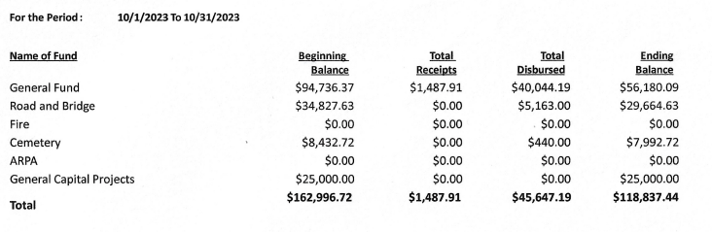

Claims for November 2023



**CONSENT AGENDA**

* October 2023 Meeting Minutes
* Treasurer Report and Bills for payment
* Payroll

Chairperson Beth Caple made a motion to approve consent agenda items, Supervisor Kevin Davidson second, motion approved.

**CORRESPONDENCE:**  MacDavitt Fire Department sent a letter stating that they are closing as they are down to 2 volunteers. This affects Ellsburg Township as we contract with them to take fire calls on the west side of Hwy 53.

**RESIDENTS AND GUESTS:**

* Heidi Yokel reported that MacDavitt Fire Department reached out and they are looking for someone to take over the coverage they had been providing for Ellsburg. Their township is considering re-opening the fire department as part of the township. The Ellsburg Volunteer Fire Department had 2 calls in November, one new member is in the process of being certified and they had power line training by area resident Barry Tegg who works for Minnesota Power. The fire department thanked the board members for approving application of Ellsburg Township as a Firewise Community so they could continue with the grant process. Firewise assessed the township and declared the township as high risk. She asked again that their monthly newsletter that is printed in the Cotton Chronicle be added to the Ellsburg Township website as Firewise needs to see the effort to educate all township taxpayers. This brought about a spirited debate as the website has minimal traffic which does not address their need to reach the taxpayer base for Ellsburg. It was decided that there will be a dedicated Firewise Community area added to the township area of the website and the fire department will send a short paragraph of highlights from their monthly newsletter which will be what the public sees at-a-glance on the fire department page of the township website.

**OLD BUSINESS**

* **Road and Bridge:** 
  + Supervisor Kevin Davidson reported that the FEMA grant for the April floods was received. The total amount awarded was $16,494.88.
* **Buildings:**
  + New Building –
    - Vice Chair John Upton reported the IRRRB has added some requirements before he can send in the last several bills to be paid as part of our grant. He now needs to send certified payroll for contractors so as soon as he receives, he will submit the invoices. The grant closes September of 2024. John expects to have approximately another $8000 to submit ($4000 will be the grant share) next spring. He also stated we need to address people parking in the parking lot of the new building, ideas being add to the parking lot, maybe signage stating no parking or a designated public parking. We need to ensure vehicles are not in the way of the fire department.
    - The building is ready to be handed over to the fire department. A lease agreement draft was viewed and John shared with the fire department that they will be responsible to maintain the holding tank for the building to MPCA standards. The fire department representatives will take the lease, and the provided MPCA information, to their next meeting to share with members. The lease will be signed and keys handed over at the December 19, 2023 Town Board Meeting.
  + Well – The water passed the repeat test, there will be one more test in 30 days.
* **Cemetery/Noxious Weed:** 
  + Nothing to report on the cemetery.
  + A Noxious Weed Annual Survey is due to the county by year end which Chairperson Beth Caple will complete and send.

**NEW BUSINESS**

* Vice Chair John Upton shared that he is requesting a quote on labor to replace the old light fixtures in the two older fire department leased buildings with LED fixtures. John will get a quote on fixtures. This information will be presented to the board for consideration to add to 2024 building projects.
* SLCAT December 6 meeting has been canceled.
* Chairperson Beth Caple reported that she had multiple calls regarding a resident who parked his pontoon in the road right-of-way. She has contacted the resident and the pontoon will be moved promptly.
* Chairperson Beth Caple held a discussion regarding fire department members holding private functions or gatherings in the buildings leased from the township. She made a motion that we add verbiage to the new building lease stating the building is only to be used for fire department sponsored gatherings or functions, individual fire department member, or resident, private gatherings or functions are not allowed. She motioned that an addendum be added to the lease for the other two buildings leased to the fire departments with the same verbiage, Vice Chair John Upton second, motion approved.

As there was no further business, Chairperson Beth Caple made a motion to adjourn, Vice Chair John Upton second, motion approved. The meeting was adjourned at 7:04 P.M.

___________________________ ____________________________

Cindy Brown, Clerk Beth Caple, Chairman

__________________________

Date