**ELLSBURG TOWNSHIP MEETING** September 26, 2023

The meeting was called to order at 6:00 PM in the Ellsburg Town hall, followed by the Pledge of Allegiance.

Board members present were Chairperson Beth Caple, Vice Chair John Upton, Supervisor Kevin Davidson, Deputy Treasurer Elaine Wick and Clerk Cindy Brown. Treasurer Scott Streitz was absent.

Guests present were: Stephanie Upton, Arrlette Krog, Lee Voigt, Dale Wick, Heidi Yokel and Jane Kempton.

Clerks’ minutes for August 2023 Meeting were read.

Treasurers Report for August

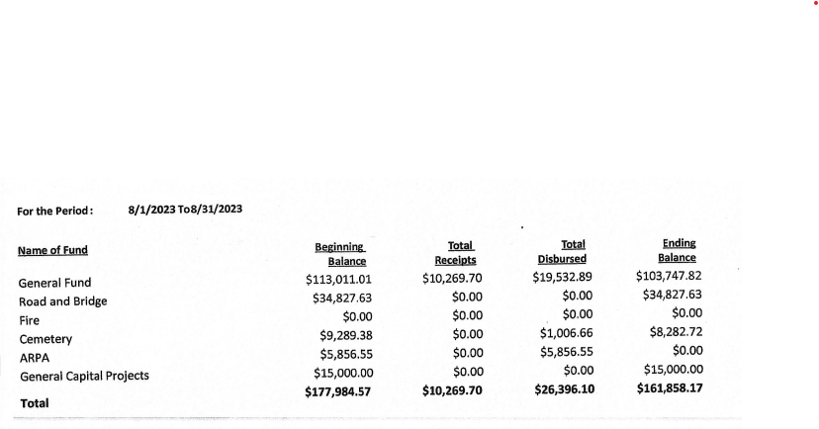

Claims for September 2023



**CONSENT AGENDA**

* August 2023 Meeting Minutes
* Treasurer Report and Bills for payment
* Payroll

Chairperson Beth Caple made a motion to approve consent agenda items, Vice Chair John Upton second, motion approved.

**CORRESPONDENCE:**  No action required.

**RESIDENTS AND GUESTS:**

* Arrlette Krog asked that a link to the article Heidi Yokel submits to the Cotton Chronicle be put on the updated website. Clerk Cindy Brown explained that she had asked Heidi to submit just a short paragraph highlighting the previous months activities for ease of reviewing fire department activities at a glance, eliminating the need for a link. The clerk will put a note on the page stating where the entire article can be found.
* Heidi Yokel stated that the fire department had no calls in September. They had 3 trucks up at Old School Lives and they were treated to a “thank you” dinner from a resident. They held a “Stop the Bleed: training class last week and encourage anyone interested in taking this important class to contact the Fire Department via email at [ellsburgvfd1102@gmail.com](mailto:ellsburgvfd1102@gmail.com)

**OLD BUSINESS**

* **Road and Bridge:** 
  + Supervisor Kevin Davidson reported that the new culverts on N. Water Hen and Nelson Roads held up well during the hard rains last weekend. He did suggest that we put additional rocks on the Nelson Rd culverts to prevent wash out in the future, he will check into cost. This cost can be added to our FEMA claim.
* **Buildings:**
  + New Building –
    - Vice Chair John Upton reported the building is up and we will move on to the inside work soon.
    - He asked the clerk to contact TAG Handyman Services to install a coded lock for ease of letting workers in the building.
    - ZJ Dirt Work will be at the site next week to fill in the sunken ground where the water line was dug, move the shed to the cemetery and take away the debris left from the building.
  + John invested the possibility of putting in a separate electricity meter for the old fire hall and neither solution available is feasible due to cost. The fire department asked the township to reconsider the 75/25 split. Chairperson Beth Caple made a motion to split the bill 50/50 going forward, Vice Chair John Upton second, motion approved.
  + A discussion was held on getting OH door openers with remotes for the old fire hall. Vice Chair John Upton will call Phils OH Door to get a quote on openers.
* **Cemetery/Noxious Weed:** 
  + Chairperson Beth Caple reported there was one urn burial last month.

**NEW BUSINESS**

* Clerk Cindy Brown shared that with bringing on a Deputy Treasurer and a Deputy Clerk the supervisors will need to outline working parameters for these positions. Chairperson Beth Caple made a motion to allow that the deputies work each week and attend each meeting for a period of 6 months for training purposes and then the supervisors will revisit the parameters of their work hours, Vice Chair John Upton second, motion approved.
* The updated MATIT appraisal for all township building was reviewed, no changes were suggested.
* Chairperson Beth Caple will contact Summit to inspect all fire extinguishers.
* The supervisors reviewed the positing for 2023/2024 Snowplowing Bid Request. They asked that we add the new building driveway to the request. Vice Chair John Upton made a motion to approve with changes, Supervisor Kevin Davidson second, motion approved.
* The supervisors continued their discussion on VRBO’s. Vice Chair John Upton shared that St Louis County have established regulations that covers the township and if we decide to generate a township specific ordinance we would have to take over the policing of VRBO’s in the township so he made a motion that we do not pursue an ordinance for the township, Chairperson Beth Caple second, motion approved.

As there was no further business, Chairperson Beth Caple made a motion to adjourn, Vice Chair John Upton second, motion approved. The meeting was adjourned at 6:50 P.M.

___________________________ ____________________________

Cindy Brown, Clerk Beth Caple, Chairman

__________________________

Date