**ELLSBURG TOWNSHIP MEETING** August 29, 2023

The meeting was called to order at 6:00 PM in the Ellsburg Town hall, followed by the Pledge of Allegiance.

Board members present were Chairperson Beth Caple, Vice Chair John Upton, Supervisor Kevin Davidson, Treasurer Scott Streitz, Deputy Treasurer Elaine Wick and Clerk Cindy Brown.

Guests present were: Stephanie Upton, Arrlette Krog, Lee Voigt, Jeff Johnson, Heidi Yokel and Jane Kempton.

Clerks’ minutes for July 2023 Meeting were read.

Treasurers Report for August

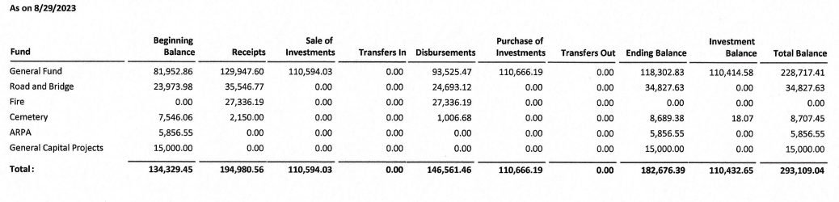

Claims for August 2023



**CONSENT AGENDA**

* July 2023 Meeting Minutes
* Treasurer Report and Bills for payment
* Payroll

Chairperson Beth Caple made a motion to approve consent agenda items, Vice Chair John Upton second, motion approved.

**CORRESPONDENCE:**  No action required.

**RESIDENTS AND GUESTS:**

* Arrlette Krog thanked the Treasurer and Deputy Treasurer for meeting with herself and Lori Mesedahl to review the 2023 Melrude Fire Hall electricity bills that the fire department is responsible to pay. She also asked the board to reconsider the current split of the electricity bill with the town hall which is currently a 75/25 split. Vice Chair John Upton will call Lake Country Power to see if electricity can be shown on the monthly invoice by building usage. She also stated the Lee Leighton Memorial was well attended.
* Heidi Yokel reported that the Ellsburg Volunteer Fire Department had two medical calls in August and two training events. She also reported the National Night Out was well attended, there were 75 attendees.

**OLD BUSINESS**

* **Road and Bridge:** 
  + New Supervisor Kevin Davidson reported that FEMA is in the Duluth area and we expect them to contact him soon to set up a meeting soon to complete the reimbursement process for work done on our flooded roads last spring.
* **Buildings:**
  + New Building – Vice Chair John Upton reported that the block has been laid, the slab has been poured and materials for the building are expected to be delivered any day now. A discussion was held to decide if we contract for the stumps to be ground down, this will be revisited next spring.
* **Cemetery/Noxious Weed:** 
  + Chairperson Beth Caple reported that the survey has been completed. She does not recommend that we put in the rock walkways that were previously discussed.

**NEW BUSINESS**

* At the July meeting the supervisors asked for a discussion on marijuana use in the township at this meeting. They learned at the MAT District 10 meeting that the township has no say in the matter so no action is required. Residents will be required to follow state guidelines.
* Vacation Rental by Owner (VRBO’s) was a topic of discussion. A copy of the North Star Township ordinance that Vice Chair John Upton obtained will be reviewed by the supervisors and a discussion will be held at the next meeting.
* Chairperson Beth Caple made a motion to transfer $5000 from the General Fund to the Cap Ex fund for 2023 and as we did not make a transfer in 2022 an additional $5000 should be transferred for a total of $10,000, Vice Chair John Upton second, motion approved.
* St Louis County sent a letter to Ellsburg Township regarding the election allocation fund set up by the State of Minnesota. The amount that Ellsburg Township is eligible to receive is $12.79. The county is asking the township to let them retain the funds as they administer absentee voting for the township. Chairperson Beth Caple made a motion that we agree to the county keeping the funds, Supervisor Kevin Davidson second, motion approved.
* Chairperson Beth Caple had requested approval to purchase a shed to house cemetery tools at the July meeting but instead made a motion at this meeting to move the rarely used shed by the basketball court to the cemetery and buy a small deck box for basketballs, Supervisor Kevin Davidson second, motion approved. We will request that ZJ Dirt Works move the building and the clerk will purchase a deck box for basketballs.
* Clerk Cindy Brown asked for approval to add the new building to our insurance as the materials will be here soon. Vice Chair John Upton also stated that when he met with MATIT on-site they were going to estimate a value on the pavilion so we can insure that as well so he made a motion to approve the clerk adding both the new building and the pavilion to our insurance, Supervisor Kevin Davidson second, motion approved.

As there was no further business, Chairperson Beth Caple made a motion to adjourn, Vice Chair John Upton second, motion approved. The meeting was adjourned at 6:56 P.M.

___________________________ ____________________________

Cindy Brown, Clerk Beth Caple, Chairman

__________________________

Date