**ELLSBURG TOWNSHIP MEETING** December 19, 2023

The meeting was called to order at 6:00 PM in the Ellsburg Town hall, followed by the Pledge of Allegiance.

Board members present were Chairperson Beth Caple, Vice Chair John Upton, Treasurer Elaine Wick and Deputy Clerk Stephanie Upton.

Guests present were: Arrlette Krog, Lee Voigt, Dale Wick and Heidi Yokel.

Clerks’ minutes for November 2023 Meeting were read.

Treasurers Report for November

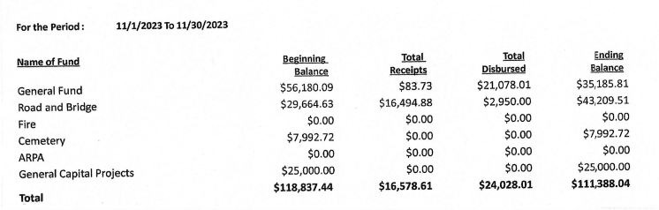

Claims for December 2023



**CONSENT AGENDA**

* November 2023 Meeting Minutes
* Treasurer Report and Bills for payment
* Payroll

Chairperson Beth Caple made a motion to approve consent agenda items, Vice Chair John Upton second, motion approved.

**CORRESPONDENCE:**  No action required.

**RESIDENTS AND GUESTS:**

* Ellsburg Volunteer Fire Department President Arrlette Krog reported that she presented the lease agreement for the new building to fire department members and they approved the lease as written. She reported that the fire department was billed for the propane to be filled, she will forward the invoice to the township so Vice Chair John Upton made a motion to reimburse the fire department as they had not yet taken possession of the building, Chairperson Beth Caple second, motion approved. We will submit to IRRRB as part of the grant program.
* Heid Yokel reported that the fire department responded to one call and they had stroke training. A discussion was held regarding the west of Hwy 53 portion of the township that is affected by MacDavitt Fire Department closing. This topic will be added to the January Town Board agenda.

**OLD BUSINESS**

* **Road and Bridge:** 
  + Nothing new to report.
* **Buildings:**
  + New Building –
    - Vice Chair John Upton reported that he received bids for completion of the building in the spring for approximately $7000.00 for reference. The work will be rebid in the spring. After the lease was signed for the new building the garage door remotes and instructions for the lock box and garage door opener were handed over to the fire department.
* **Cemetery/Noxious Weed:** 
  + Nothing new to report.

**NEW BUSINESS**

* February 6, 2024 at 2:00 pm was selected as the Board of Audit and Budget Meeting.
* Chairperson Beth Caple made a motion to approve the treasurer to pay end of year taxes, PERA and any invoices that come in for normal business through year end, Vice Chair John Upton second, motion approved.

As there was no further business, Chairperson Beth Caple made a motion to adjourn, Vice Chair John Upton second, motion approved. The meeting was adjourned at 6:29 P.M.

___________________________ ____________________________

Cindy Brown, Clerk Beth Caple, Chairman

__________________________

Date