**ELLSBURG TOWNSHIP MEETING** January 31, 2023

The meeting was called to order at 6:00 PM in the Ellsburg Town hall, followed by the Pledge of Allegiance.

Board members present were Chairperson Beth Caple, Supervisor John Upton, Treasurer Elaine Wick and Clerk Cindy Brown. Vice Chair Kevin Davidson was absent.

Guests present were: Lee Voigt, Tim Linder, Arrlette Krog, Heidi Yokel, Loren Mesedahl and Stan Johnston.

Clerks’ minutes for December 2022 Meeting were read.

Treasurer Report for December 2022

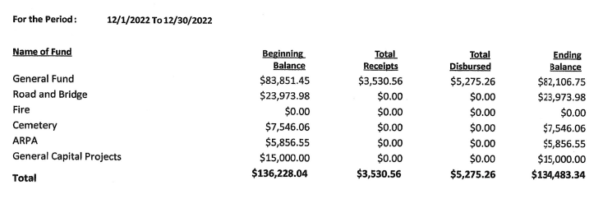

Claims for January 2023



**CONSENT AGENDA**

* December 2022 Meeting Minutes
* Bills for payment
* Payroll

Chairperson Beth Caple made a motion to approve consent agenda items, Supervisor John Upton second, motion approved.

**CORRESPONDENCE:**  South Ridge School All-Night Grad Party donation request approved. Chairperson Beth Caple made a motion to donate $200.00, Supervisor John Upton second, motion approved.

**RESIDENTS AND GUESTS:**

* Lee Voigt asked when the board was going to replace light bulbs in Melrude Fire Hall. This led to a discussion about responsibilities for general maintenance on the buildings the fire department leases from the township. It was agreed by both parties that we should hold a special board meeting to discuss, and agree to, general maintenance on all leased buildings. The special meeting will be held at Melrude Town Hall on February 21, 2023 at 6:00 p.m.
* Tim Linder stated he believes a board member is encroaching on his land via Annie Drive and wonders what the township can do about it. As it is not a town road Tim was advised the issue must be resolved between land owners.
* Arrlette Krog reported the 2023 Ellsburg Fire Department Officers are: Chief - Loren Mesedahl, Asst. Chief – Tim Linder, Asst. Melrude Chief – Lee Voigt, President – Arrlette Krog, Vice President - Heidi Yokel, Treasurer – Laurie Mesedahl and Safety Officer – Stan Johnston. She presented a list of members in good standing for consideration of the town contributing to their retirement account. She informed the supervisors that the grant they applied for to replace their obsolete radios was turned down and stated they are looking at other options. She briefed the residents on the information regarding snow removal at fire halls as presented at the January 25 SLCAT meeting.
* Heidi Yokel started to share some information but she was interrupted and all in attendance welcomed her back, it was so good to see her in attendance again! Heidi reported the 2022 fire department stats; the had 33 total calls, 11 were fire calls and 20 were medical calls. She also reported that someone had taken down their flag pole and solar light. 6 members attended a medical conference in Duluth. She also brought up the obsolete radio issue and John Upton handed her contact information for the IRRRB to see if they had grant opportunities. The radios cost $6000 each.
* Loren Mesedahl reported the fire department added several members on 2022 but they are always looking for volunteers. If interested please call Chief Loren Mesedahl at 218.391.7377.

**OLD BUSINESS**

* **Road and Bridge:** 
  + Vice Chair Kevin Davidson had some trees removed on Blackburn Drive as they were impeding the county snow plow.
* **Buildings:**
  + Supervisor John Upton stated that he is working with IRRRB to get reimbursed for half of the new Melrude Fire Department down payment. He is working with Economy Garages to prepare for the spring start to the project.
* **Cemetery:**

Chairperson Beth Caple reported that the down payment has been made for the survey that will begin this spring.

**NEW BUSINESS**

* Clerk Cindy Brown presented the election judges for approval. Chairperson Beth Caple made a motion to approve Rita Giernett (as head judge), Steph Upton and Cindy Davidson, Supervisor John Upton second, motion approved.
* Supervisor John Upton made a motion to keep the moderator pay for the March 14 Annual Town Meeting at $75.00, Chairperson Beth Caple second, motion approved.
* Clerk Cindy Brown presented the third quote of $1500.00 for updating the town website. Chairperson Beth Caple made a motion to approve the quote, Supervisor John Upton second, motion approved.
* Chairperson Beth Caple made a motion to approve the 2023 Ellsburg Volunteer Fire Department contract, Supervisor John Upton second, motion approved.
* Chairperson Beth Caple announced the annual Winter Frolic will be held on Saturday, February 18 from 11:00 – 1:30. Supervisor John Upton made a motion to donate $150.00 to the Winter Frolic, Chairperson Beth Caple second, motion approved.
* The request for PERA (retirement) contribution for 17 fire department members in good standing was reviewed. Supervisor John Upton made a motion to approve $300.00 per member for a total of $5100.00, Chairperson Beth Caple second, motion approved.

As there was no further business, Chairperson Beth Caple made a motion to adjourn, Supervisor John Upton second, motion approved. The meeting was adjourned at 7:22 P.M.

___________________________ ____________________________

Cindy Brown, Clerk Beth Caple, Chairman

__________________________

Date