**ELLSBURG TOWNSHIP MEETING** May 30, 2023

The meeting was called to order at 6:00 PM in the Ellsburg Town hall, followed by the Pledge of Allegiance.

Board members present were Chairperson Beth Caple, Vice Chair John Upton, Supervisor Kevin Davidson, Treasurer Scott Streitz, Deputy Treasurer Jill Clark and Clerk Cindy Brown.

Guests present were: Heidi Yokel, Lee Voigt, Arrlette Krog, Bill McKechnie, Sharon McKechnie, Jeremy Doesken, Louis Slatten, Steve Danielson, Charlie Danielson and Jeff Dulinski.

Clerks’ minutes for April 2023 Meeting were read.

Treasurers Report for April

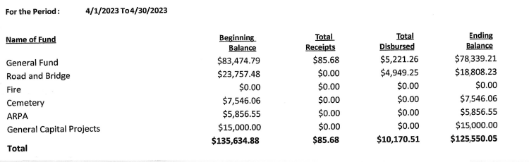

Claims for May 2023



**CONSENT AGENDA**

* May 2023 Meeting Minutes
* Bills for payment
* Payroll

Vice Chair John Upton made a motion to approve consent agenda items, Chairperson Beth Caple second, motion approved.

**CORRESPONDENCE:**  No action required.

**RESIDENTS AND GUESTS:**

* Heidi Yokel gave a fire department report. They had 4 call-outs, participated in Big Truck   
    
  Night, held NARCAN training and held a Wildland Fire Event on Berg Lake.
* Arlette Krog shared the Melrude Community Club will be holding a Fourth of July Picnic planning meeting directly after the board meeting.
* Several residents participated in a discussion on the Blackburn Drive minimum maintenance road petition. Chairperson Beth Caple invited them to express their comments but informed them that per statute the board cannot revisit this issue until one year after their prior decision. She recognized their concerns but also told them it is not as easy as “just doing it”, there are a lot of considerations that go into a decision on the township accepting a road for maintenance.

**OLD BUSINESS**

* **Road and Bridge:** 
  + Chairperson Beth Caple shared that she received a cost from Edwards Oil of chloride and calcium for township roads. Their costs are $1.19/gal and $1.25/gal.
  + Supervisor Kevin Davidson gave a report on flood damaged roads. N. Water Hen is completely repaired and Nelson Road will be done next.
* **Buildings:**
  + Vice Chair John Upton stated the new location for the fire hall building was re-staked and a permit issued.
  + Lake County Power is requiring new service for the new location. Chairperson Beth Caple made a motion to approve the application process and fee of $750.00, Vice Chair John Upton second, motion approved.
* **Cemetery:**

Chairperson Beth Caple has been in contact with the survey company and sent them an existing map.

**NEW BUSINESS**

* The supervisors held a discussion on providing punch cards for the local cannister sites (dumps) in lieu of holding dumpster days in July as in the past. They decided to purchase one (1) 5-punch card for each household in the township. Residents will have to request a card via call or email and arrange to pick up at the town hall from the clerk. The clerk will post on our standard posting boards and place a notice on the website. Chairperson Beth Caple made a motion to purchase 60 punch cards to start, Vice Chair John Upton second, motion approved.
* Melrude Whistlestop requested permission to hold two outside events this summer. Supervisor Kevin Davidson made a motion to approve the special liquor license, Vice Chair John Upton second, motion approved. Chairperson Beth Caple abstained due to conflict of interest.
* Clerk Cindy Brown requested approval to set up an on-line account with PERA. Chairperson Beth Caple made a motion to approve the request, Vice Chair John Upton second, motion approved.

As there was no further business, Vice Chair John Upton made a motion to adjourn, Chairperson Beth Caple second, motion approved. The meeting was adjourned at 6:51 P.M.

___________________________ ____________________________

Cindy Brown, Clerk Beth Caple, Chairman

__________________________

Date