**ELLSBURG TOWNSHIP MEETING** October 24, 2023

The meeting was called to order at 6:00 PM in the Ellsburg Town hall, followed by the Pledge of Allegiance.

Board members present were Vice Chair John Upton, Supervisor Kevin Davidson, Treasurer Scott Streitz, Deputy Treasurer Elaine Wick and Clerk Cindy Brown. Chairperson Beth Caple was absent.

Guests present were: Arrlette Krog, Lee Voigt, Jeff Johnson.

Clerks’ minutes for September 2023 Meeting were read.

Treasurers Report for September

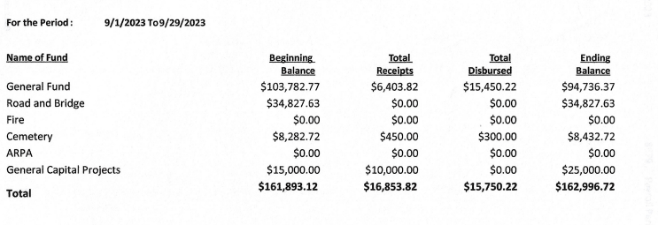

Claims for October 2023  


**CONSENT AGENDA**

* September 2023 Meeting Minutes
* Treasurer Report and Bills for payment
* Payroll

Supervisor Kevin Davidson made a motion to approve consent agenda items, Vice Chair John Upton second, motion approved.

**CORRESPONDENCE:**  No action required.

**RESIDENTS AND GUESTS:**

* Arrlette Krog shared that the fire department had their insurance reviewed and were looking forward to upcoming ortho training. Their brush rig is down and they are looking at options to repair or replace.

**OLD BUSINESS**

* **Road and Bridge:** 
  + Supervisor Kevin Davidson reported rocks have been added to the culverts on the Nelson Road to ensure no future problems due to flooding. Clerk Cindy Brown will ask that this invoice is added to the FEMA claim.
  + The only snowplowing bid received was reviewed. Vice Chair John Upton made a motion to award 2023/2024 snowplowing to TAG Handyman Services, Supervisor Kevin Davidson second, motion approved.
* **Buildings:**
  + New Building –
    - Vice Chair John Upton reported the building is getting close to completion. It still needs heat, trim, insulation and electrical. Clerk Cindy Brown will prepare a lease contract so the building can be handed over to the fire department as soon as completed.
  + Well – The water failed the water test, was treated and we are waiting for it to be retested.
* **Cemetery/Noxious Weed:** 
  + The shed from the basketball court has been moved to the cemetery.

**NEW BUSINESS**

* Vice Chair John Upton talked about the RAMS (Range Area Municipality and Schools) organization that had a speaker at the last SLCAT meeting. He made a motion for the township to join the organization if the membership cost was close to the estimated $300 annual fee he was quoted, Supervisor Kevin Davidson second, motion approved.
* Clerk Cindy Brown presented a quote for new playground equipment. The quote included installation by the company. After a discussion Vice Chair John Upton made a motion to purchase just the playground equipment at $20,427.00 and we will either hire out the assembly with a local contractor next spring or possibly organize a volunteer day in the community (TBD), John Upton will coordinate the project, Supervisor Kevin Davidson second, motion approved.
* Clerk Cindy Brown asked the fire department if they had any interest in the old table that is being replaced by the treasurer desk. Arlette Krog will inquire and let the clerk know. Vice Chair John Upton made a motion to donate the table to the fire department if they are interested, and if not asked the clerk to offer to the public, Supervisor Kevin Davidson second, motion approved.

As there was no further business, Vice Chair John Upton made a motion to adjourn, Supervisor Kevin Davidson second, motion approved. The meeting was adjourned at 6:30 P.M.

___________________________ ____________________________

Cindy Brown, Clerk Beth Caple, Chairman

__________________________

Date